Data Protection
The personal data we hold on children and families will only be used in case of emergencies and for us to be able to provide the best possible care for each child. The data is strictly confidential and we make every effort to ensure it is correct and updated regularly. It is stored securely and will not be disclosed to any third party without your consent.

Now you have read our brochure, we hope that you have a better understanding of the Centre. If you have any further questions or concerns please don’t hesitate to contact us.
Thank you for choosing St. Thomas’ Children’s Centre.


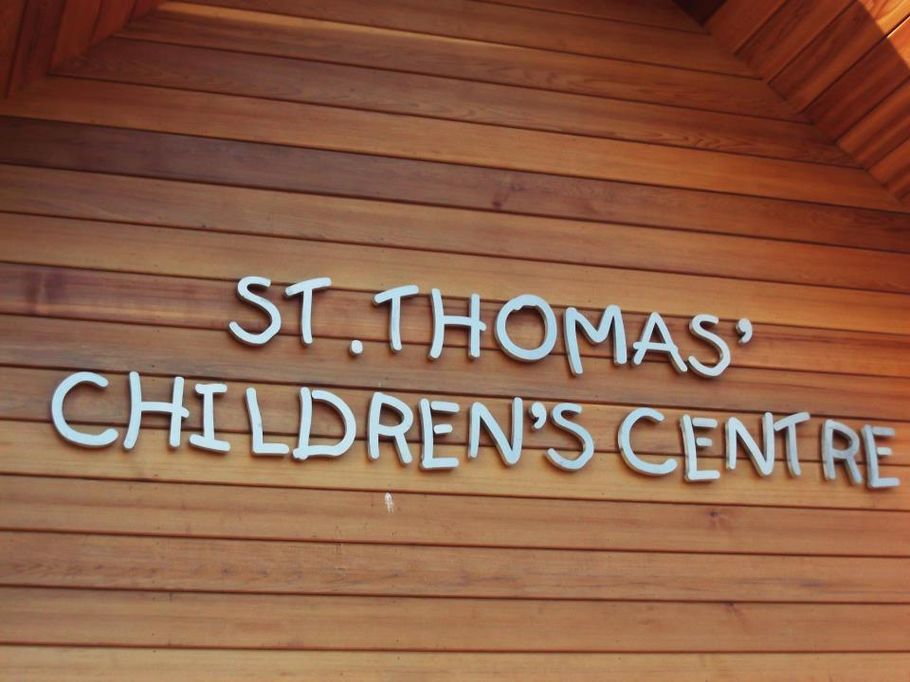

Incorporating
Breakfast Club
Pre- School


Kid’s Club

St Thomas’ Children’s Centre
Wyberton Low Road, Boston, Lincolnshire, PE21 7RZ
Tel: 01205 311227
Email: saintthomas@lowroad.fsworld.co.uk
Web: www.stthomaschildrenscentre.org.uk
St. Thomas’ Children’s Centre

Staff Structure
Centre Manager – Emma Martin
Centre Deputy Manager, SENCO & Safeguarding officer - Kelly Wilkinson
Out of School Deputy Manager – Nikki Baily
Pre- School Supervisor – Emma Scrupps
Key Persons – Emma Scrupps
Nikki Baily
Trina Reeson
Stacey England- Goddard
Beth Watson
Tina Mckue
Leoni Holdsworth
Karon Watson
Nicola Edwards
Danielle Cammack
Amie Burt
Jo Gillies
Lunch Cover and bank staff – Helen Hudson
Chairperson – Stephen Brown
Administrator – Theresa Harrop

Health and Safety
The health and safety of your child is of upmost importance to us. We inspect our premises and equipment daily, eliminating as many risks as possible. Risk assessments on our premises, equipment, outdoor area, activities and any outings are done on a regular basis. If an accident does occur and your child is involved a trained member of staff immediately gives first aid. Every accident/incident is recorded and signed. You will be asked to read and sign the document when you collect your child. We ask you to keep your child at home if they have any illnesses or infections. If your child becomes unwell while at the Centre, you will be contacted to collect them (please see copy of exclusion periods for illness policy, on website or in foyer.)
A register is taken at the beginning of every session. Named persons, as advised by yourself on your child’s registration form, can only collect your child.
Emergency evacuation procedures are held and recorded every term and fire extinguishers are checked annually. Fire exits are always kept clear. Electrical points and heaters are guarded.

Equal Opportunities
We welcome all children and families, whatever their gender or background. We will not refuse anyone on the basis of race, disabilities, gender, background, etc. the setting has positive images of different cultures by posters, books and equipment we use. We will give your child the opportunity to play with multi-cultural foods, clothing and toys, and teach them about different festivals and cultures other than their own.

Special Needs
Children of all abilities are welcome, including those with additional needs. The Centre has a full and detailed SEN policy and our named SENCO is Kelly Wilkinson, who can liaise with yourself to meet your child’s needs and offer additional support.

Behaviour Management
We aim to promote positive behaviour by encouraging self- discipline, developing consideration for others, surroundings and property, and by praising positive actions and attitudes. Inappropriate behaviour will be challenged at the time it occurs, but staff will not use any form of punishment or practices that may humiliate or frighten the child.

Introduction
We would like to take this opportunity to welcome you to St. Thomas’ Children’s Centre, and tell you about the activities and learning opportunities we offer.
St, Thomas’ Children’s Centre is a registered charity which is run by a Management Committee, who work closely with the management and ensures major decision making remains in the parent’s and children’s best interest. The Centre’s charitable status means that we rely on fee payments and fundraising. All money received is then put back into the Centre for your child’s learning and for staff development.
The staff is constantly in touch with new ideas in the field of child education and care. They regularly attend training courses and attend meetings, where they have the opportunity to share ideas and knowledge with other professionals in the childcare field.
- As a dedicated, professional and caring staff team we will offer your child:
- A planned curriculum leading to approved learning goals.
Individual care and attention made possible by a high adult/child ratio.
- Fun and friendships with other children and adults.
- Opportunities for you and your family to be directly involved in the activities of the Centre and your child’s progress.

Our Aims
- To enhance the development and education of children aged 2yrs – 11yrs in a parent- involving, community based group.
- To provide safe, secure and stimulating environments.
- To work within a framework, this ensures equality of opportunities for all children and families. (For our full aims and objectives please see the policy folder situated in the foyer or on our website.)

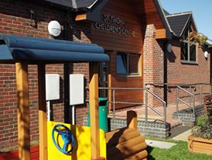
Accommodation
The Centre is situated in a purpose built building on land which adjoins St. Thomas’ C of E Primary School. Although we are a self-funding, non-profit making, independent group, we do maintain close links with the school.
To enable us to maintain a harmonious relationship with the school, we would like to remind parents of some of the school rules, mainly in respect of access to the Centre.

If you have any problems, suggestions or concerns please do come directly to discuss it with a member
of staff, they are approachable and friendly and we welcome parental input at all levels.
If, however, you feel there is a serious problem you cannot discuss with a member of staff, or the problem is not solved to your satisfaction, please contact:
Ofsted Complaints
National Business unit
Piccadilly Gate
Store Street
Manchester
M1 2WD
Tel: 0300 123 1231
Please refer to our complaints policy first
Policies
Policies are reviewed annually and are available in the foyer of the Centre as well as the Centres website (www.saintthomaschildrenscentre.org.uk ) Parent/carers will be informed of the policies being reviewed both in the newsletter and on website and comments will be invited. We have outlined some of the most relevant details for your information,

Please let us know if your child contacts an infectious illness, e.g. chicken pox, impetigo, measles or mumps. There is a full list of illness and diseases in our policy folder, found in the foyer or on our website. Plus there is a list displayed on the foyer wall
- Staff members must be notified if another adult is collecting your child.
- The Centre cannot be held responsible for loss or damage to children’s property.
- It would be helpful if your children are dressed in clothing and footwear which is suitable for play both indoors and outdoors.
- Jewellery and large earrings should not be worn by the children at pre-school.
- Children should be encouraged not bring in their own toys and sweets, except comforters during the settling in period.
- At Pre-School any work your child has produced within the session, plus newsletters and other important information will be placed in their tray. Please check your child’s tray when you collect them.
- Each child attending pre-school will be allocated a key person. You will be notified of your child’s key person during their first session with us.

- No parking is permitted on the restricted areas outside the gates.
- Please use the schools main gates for access, not the green wooden gate adjoining us. This is for us to use to transport our children safely to and from school to our out of school sessions.

Times and session information.

- Breakfast Club (Monday – Friday) 7.45am – 8.40am
- Pre-school (Monday – Friday)
- Morning session 8.50am – 11.50
- Afternoon session 12.00pm – 3.00pm
- Full day 8.50am – 2.50pm (extra care can be offered until 3.00 extra charge applies)
- Kid’s Club (Monday – Friday) 3.05pm – 4.30pm
- or 3.05pm- 6.00pm
Due to insurance cover, children should not be left unattended prior to the session starting and should be collected promptly at the end of the session.
Term dates for all sectors of St. Thomas’ Children’s Centre are the same as St. Thomas’ C of E Primary School.

Admissions
Children are admitted to St. Thomas’ Pre-School from the age of 2yrs and admitted to attend out-of-school clubs once they start attending St. Thomas’ C of E Primary School. Children are admitted by virtue of age and availability of places. Places are offered in the first instance to those children who are eligible to receive Early Years Entitlement funding, as required by Lincolnshire County Council.
Fees
Fees are due whether your child attends a session or not, However if your child will be away on holiday and you give us 4 weeks’ notice you will receive a 50% reduction of fees. If your child is absent due to a prolonged illness, please notify the manager, as they may be able to fill these places, and fees may alter. (Each case will be at manager’s discretion)
From Sept 2013
Pre-School £10.65 per session of 3 hours
Full day £21.30 extra care £1.00
Kid’s Club £3.40 or £6.80
Breakfast Club £2.75
Late Collection £5.00 up to 15 minutes
£10.00 for every 15 minutes after that
(see full fees and payment policy for details of other charges and payment information)
Funding
The Centre is registered as a Nursery Education provider which enables us, in respect of children of the appropriate age, to claim a grant from the local education authority for the child’s fees for a maximum of 15hrs per week, term time only. (Pre-school only)
- Family tax credit – parents may be entitled to claim FTC and can then in certain circumstances claim them for childcare: please see the administrator for information
- Childcare vouchers – we are registered for childcare vouchers: please see administrator for information.

General Information for parents
- We accept children from the age of 2yrs at pre-school and they don’t need to be toilet trained. We have potties and trainer seats plus spare clothes for accidents. We will work with families when they decide the appropriate time for toilet training. Please supply your child’s own nappies.
- For security reasons the door will be locked during any session, and is secured by a remote entry system. There is a reception area which is always open for enquiries and a bell if no one is available in the office at the time you call.
- Healthy snacks are served during each session, and so it is vital that we know if your child has any allergies or major dislikes. If your child comes to us for a full day at pre-school you need to provide them with a packed lunch and drink.
As always, these are only guidelines and we understand that each child’s needs can differ greatly.

